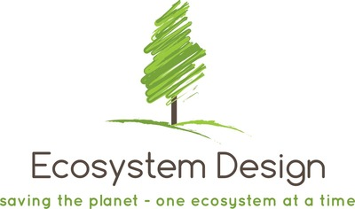

Condensed Permaculture Design Report Template

Contents
1. Introduction 4
2. Site Analysis 4
Location: 4
Topography: 4
Soil: 4
Water: 5
3. Design Overview 5
Zones: 5
Key Elements: 5
4. Implementation Plan 5
Phase 1 (Months 1-6): 5
Phase 2 (Months 7-12): 6
Phase 3 (Year 2-3): 6
Budget Estimates: 6
5. Maintenance and Monitoring 6
Regular Tasks: 6
Monitoring Systems: 6
Adaptation and Improvement: 7
6. Education and Community Involvement 7
Workshops and Events: 7
Outreach: 7
7. Appendices 7
Key Resources: 7
Soil Test Results: 8
Detailed Budget Breakdown: 8
Maintenance Logs: 8

[Green Haven Homestead]: Condensed Permaculture Design Report

1. Introduction

Project Overview:
6 hectares undeveloped property in Mahammadi village, Absheron. The owner’s vision is to build an organic food production system for own consumption and commercial use. At this stage, the owner is considering various options in terms of revenue streams and enterprises at the site.

2. Site Analysis

Location:

- Mahammadi, Absheron, Azerbaijan.
- Semi-arid / dry subtropical climate. Mild-hot summers, relatively mild winters.

Temperature
- Average annual temperature is about 14 °C.
- In January the average is roughly 3-4 °C.
- In July/August average temperatures reach about 35-36 °C.
- Extremes: very rarely it can get up to ~42 °C in peak summer, and down to about -20 to -21 °C in severe winter cases for coastal zone

Temperature ranges by month

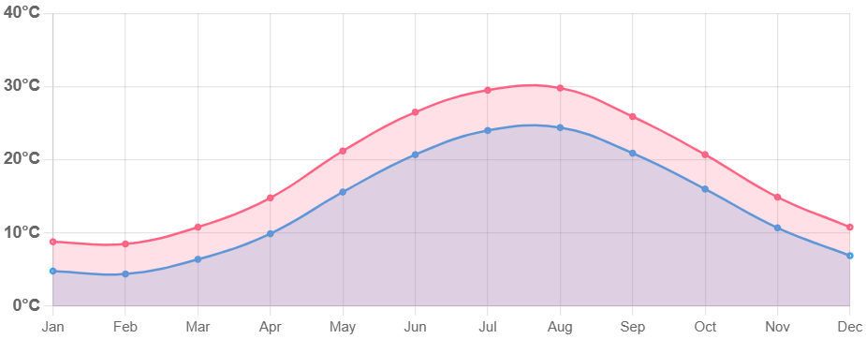

Precipitation & Rainfall

- Low annual rainfall — somewhere around 200-250 mm/year on average.
- Rain is unevenly distributed: more in autumn & winter; summer months are very dry with often <5 mm in driest months.
- Snow is rare, occurs only a few days a year, and contributes a small portion of total precipitation.

Monthly Precipitation Levels

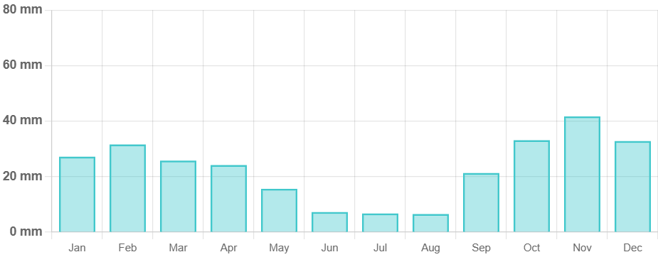

Relative humidity over the year

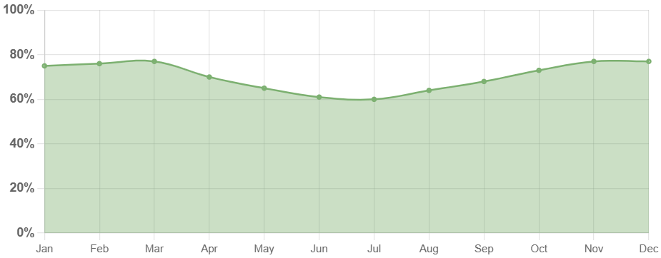

Topography:

- Gently sloping terrain suitable for water management features like swales and ponds.
- The slope is from South-West to North-East

Winds & Other Features
- The region is well known for strong winds. Two named winds are especially characteristic:
  - Khazri: a north or north-west wind, cold, especially in winter.
  - Gilavar: a warmer south wind, more felt in summer, tends to moderate cold in winter.
- Proximity to the Caspian Sea moderates extremes (keeps winter a bit milder, summer not as extremely hot as inland in same latitude).

The mean monthly wind speed over the year (meters per second)
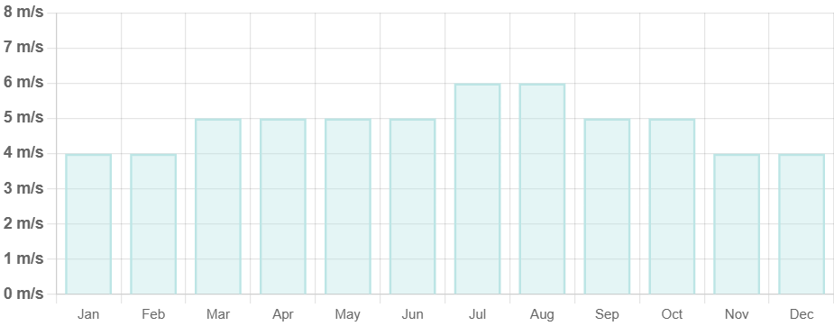

Soil:

- Sandy loam soil with poor fertility.
- Recommendations: Add compost and organic matter to improve soil health.

Water:

- Average annual rainfall: 200-250mm.
- Water sources:
  - There is a pipe with irrigation water near the boundary of the property,
  - Rainwater harvesting potential from structures to be built on site,
  - Potential for greywater reuse,
  - Possibility of well water to be researched by owner.

3. Design Overview

Windbreak

There is no windbreak on site. Windbreak to be considered along perimeter of the property. The windbreak to be comprised of variety of trees. Specifically:
- Evergreen species along the Northern boundary of the property. This will ensure effective protection from Northern winds in Winter
- Deciduous trees on the Southern side of the property. This will ensure the tree line does not block the sun in Winter when the sun is low in elevation.

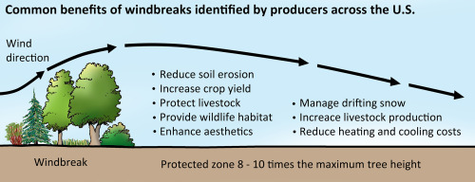
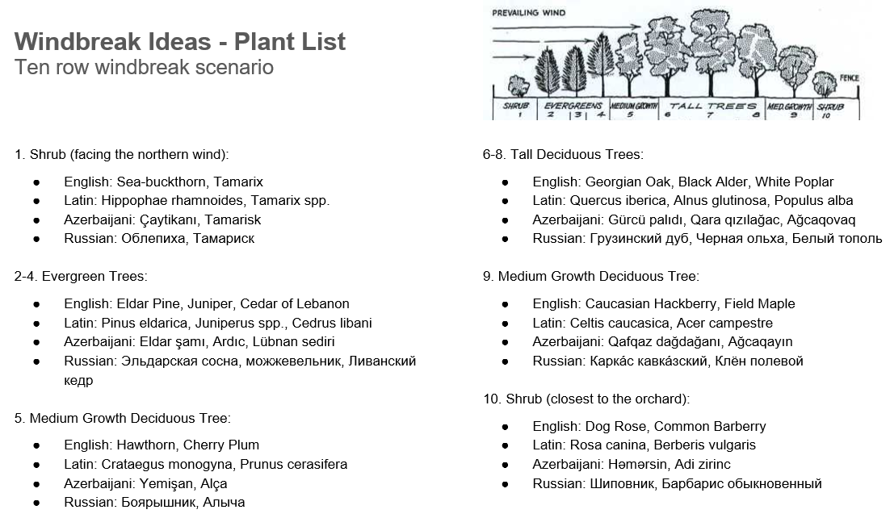

Sun Aspect
Orientation towards the sun must be kept in mind when planning construction of housing (Western side hottest in the afternoon), orchard and greenhouse design (North to South).

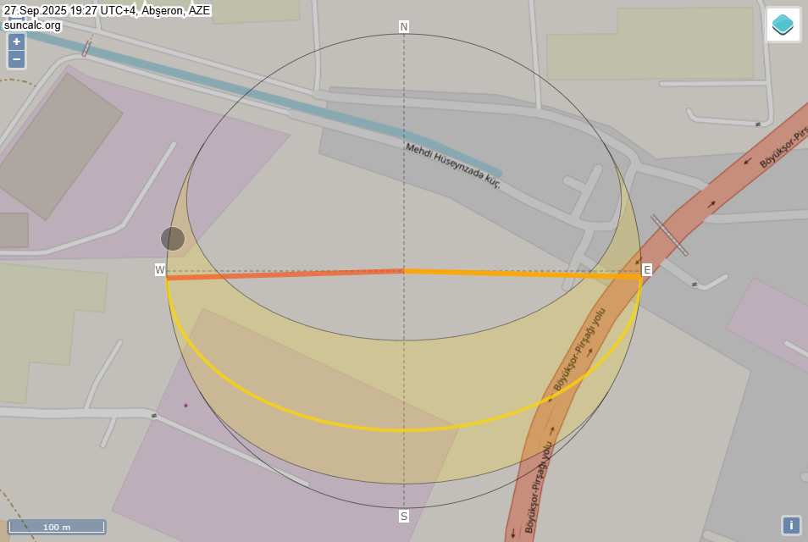

Monthly hours of sunshine

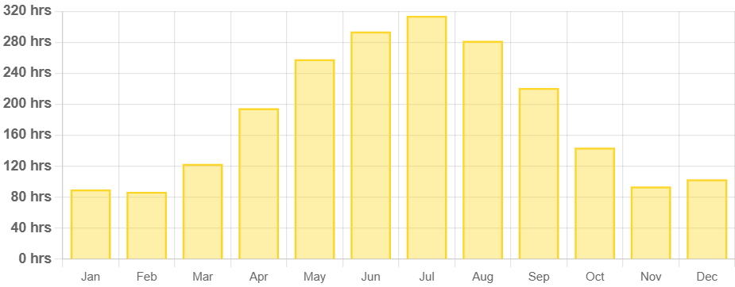

Daily hours of sunshine

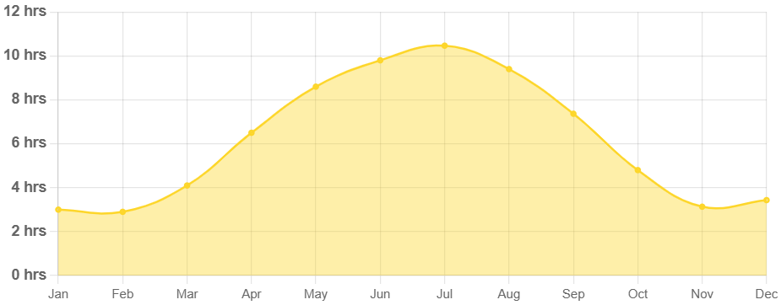

Zones:

Zoning is not yet possible due to very early stages of design development. Once the structures put in place, zoning will be possible.
- Zone 1: Home garden with herbs, vegetables, and small fruit trees.
- Zone 2: Larger fruit trees, small livestock (chickens, bees).
- Zone 3: Staple crops, larger livestock, and forage areas.
- Zone 4: Agroforestry and managed woodlands.
- Zone 5: Natural wilderness for biodiversity and ecological balance.

Key Elements:

- Water Management: Swales, ponds, rainwater harvesting systems.
- Energy Systems: Solar panels, potential for wind turbines.
- Soil Building: Composting, cover cropping, mulching.

Enterprises to be considered:
- Poultry-centered orchard (tree-range farm style)
  - Key elements: 1 chicken coop for 1,600 broilers or egg producers for 1 hectare of orchard. The orchard is split in two parts and the coop is in the middle. The chicken feeding is done during day time outside only with only drinking water inside the coop.
  - More info: https://drive.google.com/file/d/1ToO12b6M5a40h9vyqOiF_3wuDAAlTdQn/view?usp=drive_link
  - Syntropic approach could be considered: https://www.youtube.com/watch?v=_W7YYTyNnWc
  - Syntropic agroforestry in Mediterranean: https://www.youtube.com/watch?v=XEu84WTq-LU
- Poultry centered market garden (Geoff Lawton style)
  - Key elements: Chicken coop in between the market garden with chicken fenced in at all times. Compost production inside the coop with intensive market garden outside.
  - 30 chickens = 1m3 compost = 2000 m2 market garden
  - 50 chickens = 2m3 compost = 4000 m2 market garden
  - More info: https://www.youtube.com/watch?v=hi5eDdGzLK8&t=529s
- Greenhouse
- Productive windbreak / food forest
- Commercial compost production (if enough material available)
- Vermicomposting (if enough material available)

4. Implementation Plan

Phase 1 (Months 1-6):

- Site preparation, initial infrastructure setup (water systems, composting).
- Planting initial garden beds and cover crops.

Phase 2 (Months 7-12):

Expanding gardens, installing renewable energy systems.
Introducing small livestock and completing swales and ponds.

Phase 3 (Year 2-3):

Full planting of staple crops, advanced water systems.
Community engagement programs and workshops.

Budget Estimates:

- Phase 1: $5,000 - $8,000
- Phase 2: $4,000 - $7,000
- Phase 3: $6,000 - $9,000

5. Maintenance and Monitoring

Regular Tasks:

- Daily: Watering, livestock care, garden monitoring.
- Weekly: Composting, plant health checks, system inspections.
- Monthly: Soil testing, pruning, structural maintenance.
- Seasonal: Planting/harvesting, mulching, energy system checks.

Monitoring Systems:

- Soil health, water usage, plant growth, and energy production.

Adaptation and Improvement:

- Regular reviews and feedback loops to adjust practices and improve systems.

6. Education and Community Involvement

Workshops and Events:

- Basic permaculture principles, composting, water management.
- Community garden projects, open farm days, seasonal festivals.

Outreach:

- Social media updates, newsletters, collaborations with local schools and organizations.

7. Appendices

Key Resources:

- Books:
  - "Permaculture: A Designers' Manual" by Bill Mollison
  - "Gaia’s Garden" by Toby Hemenway
- Websites:
  - Permaculture Research Institute (permaculturenews.org)
  - Permies.com (permies.com)
- Local Suppliers:
  - Seeds, plants, tools, and materials.

Soil Test Results:

- Initial analysis and recommended amendments.

Detailed Budget Breakdown:

- Itemized for each phase, including materials and labor.

Maintenance Logs:

- Templates for daily, weekly, monthly, and seasonal tasks.

This condensed report provides a streamlined approach to developing the Green Haven Homestead permaculture project, suitable for clients on a budget who require essential information and actionable steps without the comprehensive details of a full report.

